Invitation to tender
for the design and re-development of Pheasant Hill Playground and additional equipment at Bowstridge Lane Recreation Ground, Chalfont St Giles

CONTENTS
Project Overview 3
Budget 3
Timetable for Project 3
Tender Instructions and Guidance 4
Questions 4
Site Meeting 4
Notice of Intent to Bid 5
Decision and Award of Contract 5
Supplier Submissions 5
Non-Consideration of a Tender Response 5
Contract Conditions 5
Specification of Works 6
Post Installation 8
Scoring Criteria 8
Submission checklist 9
Appendix a 10

Deadline for tender submissions Friday 27 January 2022 at 1pm.

Project Overview
This document has been prepared by Chalfont St Giles Parish Council for the purpose of inviting proposals from a suitably qualified company to design and re-develop an existing playground facility located at Pheasant Hill, Chalfont St Giles, Buckinghamshire HP8 4QB
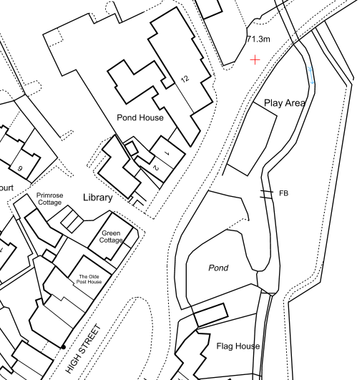
and to add an accessible roundabout to the Bowstridge Lane Recreation Ground play area, Crossleys, Chalfont St Giles, Buckinghamshire HP8 4QU.
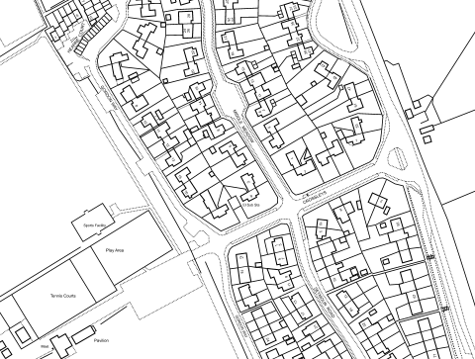
Budget
The Council has agreed a budget of £70,000 (Ex VAT) for the project. All pricing should be exclusive of VAT and in GBP (£). Pricing should be valid for a minimum of 90 days from the due date of the response. Prices will be fixed for the duration of the contract.
Timetable for Project
Applicants will need to adhere to the timescales set out below.
Action |  | Date
Issue invitation to tender | The Council will publish on:  • Chalfont St Giles Parish Council Website  • Contract Finder | Monday 12 December 2022
Notification of Intention to Bid | Interested parties are to notify the Council by email of their intention to submit a tender | Wednesday 4 January 2023
Site visits | Site visits will be conducted | Tuesday 20 December 2022
Deadline for questions | All questions should be submitted via email to the named contact | Wednesday 21 December 2022
Deadline to receive tenders | Tenders should be submitted in line with guidance below | Friday 27 January 2023 at 1pm
Approval of contractor | Due to the Council meeting diary the successful contractor will be notified no later than. | Wednesday 1 February 2023
Final design agreement | Council agreement of design and costing | Friday 10 February 2023
Work to take place | Work should be completed by: | Completed by end March 2023.
Tender Instructions and Guidance
Named Contact for Project
All contact should be with either:
Helen Griffiths (Clerk) via clerk@chalfontstgiles-pc.gov.uk or
Jane Chamberlain (Councillor) Jane@chalfontstgiles-pc.gov.uk
Suppliers are forbidden to approach any person/s outside of the named contacts within this document in relation to this tender and project. Failure to adhere to this requirement may result in disqualification from the tender process.
Questions
Any questions relating to this tender must be raised in writing no later than Wednesday 21 December 2022 at 3pm. Questions should be addressed to Helen Griffiths (Clerk) using the designated e-mail only.
Please note that the questions raised and responses during the tendering period will be added to the Parish Council website and may be circulated to all tenderers.
Site Meeting
There will be the opportunity to attend a site meeting, along with other interested contractors, on Tuesday 20 December 2022. If you would like a member of the Parish Council to be available for the site visit these are by appointment only. Otherwise, contractors are welcome to visit the site at their own convenience. This is not mandatory.
If attending a site visit, we request that only one person from each supplier is present.
Appointments can be booked via clerk@chalfontstgiles-pc.gov.uk
Notice of Intent to Bid
Suppliers should inform the Parish Council of their intent to submit a tender by Wednesday 4 January 2022. Failure to do so may result in your organisation not receiving updates to the Tender Process or any circulated responses to questions.
Decision and Award of Contract
The Council will use the scoring criteria set out within this document to decide on the contract. All suppliers who have submitted a formal tender will be notified of the outcome by email.
Supplier Submissions
The tender submissions received by the Council will not be shared with other suppliers.
Non-Consideration of a Tender Response
The Council has the right to refuse tenders and withdraw the project without suppliers being able to claim compensation. All costs related to the tender process are the responsibility of any tenderers who wish to apply.
The Council may refuse a tender response if the information required by the Council to make a full evaluation has not been provided.
Anything other than “appropriate” communication made with the Council’s named contacts, such as raising any questions or clarifying points relating to the tender, may be considered a breach in the procurement process.
Contract Conditions
Works and Standards
The work is for the design and redevelopment of Pheasant Hill play area and additional equipment at Bowstridge Lane play area. This includes the supply and installation of appropriate groundworks, safety surfacing, play equipment, fencing and signage. The contractor is also responsible for the removal of existing equipment, as agreed with the Council. Specified fencing is to be retained.
All works should comply to the British and European Standard for playground equipment BS EN 1176 and surfacing BS EN 1177.
The contractor will be responsible for organising an independent post-installation inspection and rectifying any issues identified at their own cost. The Parish Council will not accept hand over of the area until identified issues are rectified.
Health and Safety
The contractor must comply with all relevant health and safety regulations and is responsible for securing the site during construction, including the use of fencing where appropriate. Appropriate signage will be added to the site with contractor details displayed. The contractor is also responsible for securing their equipment on site. The Council will not be held liable for any loss or damage to equipment or injury to members of public during construction.
Insurance
The successful contractor must have the following cover in place:
- Public Liability Insurance of no less than: £10 Million
- Product Liability Insurance of no less than: £5 Million
- Employers Liability Insurance of no less than: £5 Million
- Professional Indemnity Insurance of no less than: £1 Million
Evidence of this cover must be provided at the initial quotation stage.
Additional Documentation
A Schedule of Works with a commencement and completion date and a Risk Assessment and Method Statement must be provided prior to work commencing.
Specification of Works
Pheasant Hill play area is a well-used playground located in the centre of the village. The current playground consists mostly of ageing metal equipment with safety matting. The equipment and surfacing is showing signs of wear and needs replacement. The play equipment currently included in the play area lacks play value and is not accessible to all. The Parish Council is seeking to include play equipment with higher play values that is inclusive and accessible to all. The equipment should cater mainly for children between 1 and 7 years.
Following public consultation, the equipment we would like included in the Pheasant Hill play area are:
Multi-play
Swings -basket or regular
Springers
Roundabout
See saw
Due to the proximity of the play area to the River Misbourne, the area is prone to flooding approximately once every 4 years. This means that equipment that is recessed into the ground is not appropriate in this area. These conditions mean that the following must be taken into consideration:
- Only include roundabouts or other equipment that do not have the mechanics sunk into the ground
- All wooden equipment must have steel feet.
- Surfaces and sub base must be suitable for areas that flood.
Bowstridge Lane play area is situated at the Recreation Ground. The play area was refurbished in 2015. The addition of an accessible roundabout and surfacing would complete this area.
Materials
The Parish Council are willing to consider equipment made of different materials e.g. wood, plastic and steel pieces. However, due to the heavy use of the playground, equipment must be robust and vandal-proof.
Design Considerations
As the play area is within the Chalfont St Giles Conservation Area and within the ‘natural’ environment of Riverside Walk, colours that reflect the environment are required including blues, greens and browns.
The duck pond is a central feature of the village centre and the River Misbourne runs through the village. Plans should incorporate nature within the designs and consider these features.
The equipment proposed must not be over 4 metres high to comply with planning restrictions.
The Parish Council also wishes to include appropriate safety surfacing to deliver a cohesive play experience. Any specified material must be hardwearing and offer longevity and be cost effective.
Environmental Considerations
The Parish Council are environmentally aware and is interested in reducing carbon emissions and mitigating its impact on the environment wherever possible. Applicants that can demonstrate environmentally friendly policies regarding the manufacture, recycling and disposal of equipment will be looked on favourably.

List of minimum equipment required at Pheasant Hill.
Item | Requirements
Swings | Basket, adult/child, cradle will all be considered
Pre-school/Toddler multi-play unit | The piece should be exciting and challenging, with added play value, aimed at children 1-7yrs and should include some of the below:  slide(s)  walkways/bridges,  tubes/tunnels  climbing wall  climbing ropes  fireman’s pole  base area accessible to younger children/wheelchair users with interactive elements.
See Saw | Traditional
Springers | To reflect the area, duck, fish, natural designs.
Roundabout | This must be accessible but not recessed into the ground because of flooding issues.
Additional Equipment | Activity boards, speaking tubes
Surfacing | Wet Pour is preferred
Fencing | The additional fencing must match the existing fencing.
Gate | An additional gate is to be installed at the north end of the play area.
Signage | Signage to be added to the external gates of the play area to include details that will be provided by the Parish Council.
Disposal | All equipment at Pheasant Hill will need to be disposed of.
List of minimum equipment required at Bowstridge Lane.
Item | Requirements
Roundabout | Accessible roundabout
Surface | Suitable surfacing to connect new equipment to existing path.
Post Installation
A full list of equipment supplied will be provided to the Parish Council. For each item included, the warranty period must be specified along with the items to be checked on weekly routine inspections.
Scoring Criteria
Description | Evidence | Scoring
Tender received on time | Confirmation of receipt of tender | Pass/Fail
Ability to deliver project within the specified timeframe | Confirmation of expected timescales | Pass/Fail
Insurance at the specified level | in-date Certificates | Pass/Fail
Certificate of Collusion | Signed Certificate | Pass/Fail
Two Business References | Result of enquiries to references | Pass/Fail
Health and Safety Policy | Copy of policy | Pass/Fail
Quality of Design | Compliance with specification. Ability to cater to all ages and abilities Well-designed layout. | 40%
Materials | Quality of materials used, Expected life-span for equipment Reliability of supply chain and spare availability. | 15%
Environmental credentials | Evidence of sustainable approach and policies relating to manufacture, recycling and disposal of equipment. Carbon emissions relating to supply chain and manufacture. | 5%
Price/Value for money | Quote for current project Cost of replacements Warranty cover Deliverance of project aftercare service | 40%
Submission checklist
Please ensure the following are included with your submission:
• Application form
• Draft playground design and quotation
• Product details
• Warranty details
• Copies of Insurance Certificates
• Maintenance requirements
• Costing and lead time for availability of spare parts
• References
• Requested policies
• Delivery and installation timetable.
An email or electronic transfer of all the above responses should be sent by the tenderer submission deadline to clerk@chalfontstgiles-pc.gov.uk by Friday 27 January 2022 at 1pm. Hard copies should also be sent to the Parish Council Office, Gravel Hill, Chalfont St Giles, Buckinghamshire, SL9 9QX..

Appendix a
Area in red is the existing play area, area in blue is the area we wish to extend the play area into.
