Monitoring borehole works at Stone Meadow, Chalfont St Giles
November 2021 | www.hs2.org.uk
High Speed Two (HS2) is the new high speed railway for Britain. As part of our monitoring during the construction of the Chiltern Tunnel, we need to drill a number of boreholes for monitoring equipment along the route of the Chiltern Tunnel.  Where and what are the works taking place?  We will be carrying out borehole drilling in the field on Stone Meadow, Chalfont St Giles on Monday 15 November to Friday 14 January  Before we can start the borehole excavation, we will need to prepare the area on Stone Meadow across to where the location of the boreholes will be. We will do this by laying ground protection mats, known as ‘track matting’. This is so we can safely move the equipment in out and out of the field to level the ground, without damaging the field. We will then level the area where the borehole will be prior to drilling.  A small number of vehicles including heavy goods vehicles (HGVs) will be used for these works for delivery of equipment.  Once the drilling rig is in place a bowser will transport water to the site two or three times a day, as the drilling process requires a regular supply of water. The water will be supplied from the Chalfont St Giles vent shaft site.  Once drilling is complete, we may visit from time to time for the duration of the project as the tunnel boring machines move through. Once they have passed, the borehole equipment will be removed  If you have a question about HS2 or our works, please contact our HS2 Helpdesk team on 08081 434 434  or email hs2enquiries@hs2.org.uk |  |  | Duration of works  Monday 15 November to Friday 14 January  8am to 6pm Monday to Friday. We may also be on site for one hour’s start up and shut down outside of those times  What to expect  A small number of vehicles entering and leaving the site each day whilst works are taking place. These are 4x4 type vehicles. HGVs will be used for delivery and collections of the Rig and track matting. There may be some low noise from the drilling rig used to create the borehole  What we will do  Respond promptly to any queries or complaints and take appropriate action

Notice of Borehole works at Stone Meadow, Chalfont St Giles | Notification
www.hs2.org.uk

Who will be on site?
A small number of staff will be present during the day and security staff will be on site 24/7. There will be fencing around the drilling rig which will remain on site until the works are complete. Please see an example on page three of this notice on how the work site will look.

Residents may notice some drilling noise during working hours; however, we will do all we can to minimise this.

Location of the works.
Indicated below by blue dots.

Notice of borehole works at Stone Meadow, Chalfont St Giles | Notification
www.hs2.org.uk

Will you impact the Public Rights of Way on the site?
We will not impact Public Rights of Way on the site.
What will be on the site during the works?
Below is an example of the type of rig which will be used to drill the borehole and the completed monitoring borehole.
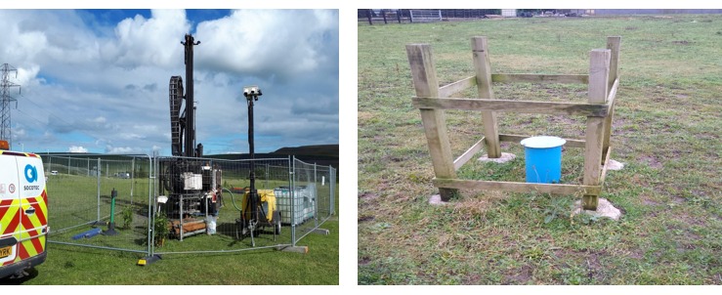

Keeping you informed
We are committed to keeping you informed about work on HS2. This includes ensuring you know what to expect and when to expect it, as well as how we can help.
Residents’ Charter and Commissioner  The Residents’ Charter is our promise to communicate as clearly as we possibly can with people who live along or near the HS2 route.  www.gov.uk/government/publications/hs2-residents-charter  We also have an independent Residents’  Commissioner whose job is to make sure we keep to the promises we make in the Charter and to keep it under constant review. Find reports at:  www.gov.uk/government/collections/hs2-ltd-  residents-commissioner  You can contact the Commissioner at:  residentscommissioner@hs2.org.uk  Construction Commissioner  The Construction Commissioner’s role is to mediate and monitor the way in which HS2 Ltd manages and responds to construction complaints. You can contact the Construction Commissioner by emailing:  complaints@hs2-cc.org.uk  Property and compensation  You can find out all about HS2 and properties along the line of route by visiting:  www.gov.uk/government/collections/hs2-property  Find out if you’re eligible for compensation at:  www.gov.uk/claim-compensation-if-affected-by-hs2  Holding us to account  If you are unhappy for any reason you can make a complaint by contacting our HS2 Helpdesk team. For more details on our complaints process, please visit our website:  www.hs2.org.uk/how-to-complain | Contact Us  Contact our HS2 Helpdesk team all day, every day of the year on:  Freephone 08081 434 434  Minicom 08081 456 472  Email hs2enquiries@hs2.org.uk  Write to:  FREEPOST  HS2 Community Engagement  Website www.hs2.org.uk  To keep up to date with what is happening in your local area, visit: www.hs2inyourarea.co.uk  Please contact us if you’d like a free copy of this document in large print, Braille, audio or easy read. You can also contact us for help and information in a different language.  HS2 Ltd is committed to protecting personal information. If you wish to know more about how we use your personal information please see our Privacy Notice https://www.gov.uk/government/publications/high-speed-two-ltd-privacy-notice

Reference number: HS2-EW-Align-Ph1-Ar-Ce-C2-Prog-works-25-31/10/2021

High Speed Two (HS2) Limited, registered in England and Wales.
Registered office: Two Snowhill, Snow Hill Queensway, Birmingham B4 6GA.
Company registration number: 06791686. VAT registration number: 888 8512 56.

