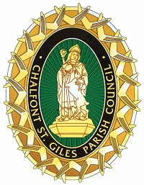
CHALFONT ST. GILES PARISH COUNCIL

NOTICE OF The Annual MEETING OF THE PARISH COUNCIL

The Annual Meeting of Chalfont St. Giles Parish Council will be held on Tuesday 18 May 2021 immediately after the conclusion of the Annual Meeting of the Parish but not before 7.45pm, in the Memorial Hall, School Lane, when the business set out below is to be transacted.

Please DO NOT attend if you or anyone in your household has had COVID-19 symptoms in the last 7 days.
All participants will be socially distanced at 2m apart and requested to use hand sanitiser when entering and leaving the building. You will be required to scan a track and trace QR code or to sign in to the meeting, so please bring a pen with you. You will also be required to wear a mask. Do bring a coat as the doors and windows will be opened for ventilation.

AGENDA

- To elect a chairman
- To elect a vice chairman
- Apologies for absence
- To agree the minutes of the Annual meeting of the council in 2019.
- Councillors to sign the declaration of acceptance of office.
- Councillors to be appointed to committees
- To appoint the representatives to Local Organisations
- To agree the meeting dates for the year
- To resolve to adopt the General Power of Competence in accordance with the Localism Act 2011.

